Abstract

This system aims at maintaining patient health records and even getting appointments from various doctors for related treatments. The Health Prediction application is an end user support and online consultation project. Here we propose an android application that allows users to get instant guidance on their health issues through an intelligent health care application online. The system user must register as a member of this system and keep updating his medical history. Patients can then select from a list of specialized doctors for respective treatments at particular locations. Patients may also select suitable appointment timings for their meeting.

The application allows user to share their symptoms and issues. It then processes user’s symptoms to check for various illness that could be associated with it. Here we use some intelligent data mining techniques to guess the most accurate illness that could be associated with patient’s symptoms. The application also has a doctor login, where the uploaded information are sent to respective doctor along with patient contact details. The doctors may now contact the patient for further process.

Chapter 1-Introduction

Project Name : Health Plus

Module : Android Application

Front End : Android

Back End : MySQL

Tool : php

The Health Prediction application is an end user support and online consultation project. Here we propose an android application that allows users to get instant guidance on their health issues through an intelligent health care application online. The system user must register as a member of this system and keep updating his medical history.

1.1 Specification:

Hardware Specification:
- Pentium processor
- 40GB or 80GB Hard disk
- 1-44 Floppy disk
- 4.6 MB RAM
- CD ROM, Storage media for backup

Software Specification:
- Windows
- Android studio
- MySQL
- Java

1.2 Detail Description of Technology

- Android Studio:
Android Studio is the official integrated development environment (IDE) for Google's Android operating system, built on JetBrains' IntelliJ IDEA software and designed specifically for Android development. It is available for download on Windows, macOS and Linux based operating system. It is a replacement for the Eclipse Android Development Tools (ADT) as primary IDE for native Android application development.

- MySQL:
MySQL is an open-source relational database management system (RDBMS)
based on Structured Query Language (SQL). The application is used for a wide range of purposes, including data warehousing, e-commerce, and logging applications. The most common use for mySQL however is for the purpose of a web database.

- PHP:
PHP is a server scripting language, and a powerful tool for making dynamic and interactive Web pages.PHP is a widely-used, free, and efficient alternative to competitors such as Microsoft's ASP.

Chapter 2--Project Plan

  - Project Name: Health Plus

  - Project Approach

Phase 1: Gathering the softwares required for the system building.
Phase 2: Developing the Core components.
Phase 3: Building the Sign up and registration page.
Phase 4: Integrating all the components.
Phase 5: Testing the system
Phase 6: Deploying

2.3 Synopsis
Scope:
-Online Doctor Appointment .
-Doctor will be able to view appointments.
-Medical history updating.
-The user can find doctor in his/her locality.
-Knowing disease by providing symptoms.
-Provide feedback.
2.4 Goals and Objectives:

-The system has integration of various functionality which helps user to communicate easily.
- The system also provides the user a chatbot which helps user to use the app easily.
- The user uploads medical history which the doctor may go through before the appointment .
- The doctor will get the number of appointments per day before hand.

Chapter 3--Project Requirement

3.1 Requirements:

-The user should be signed up only when he is registered.
-The user name and password should match.
-The user should get all the doctors in the locality provided.
-The appointment must be booked.
-The doctor must view the medical history of the patient.
-Then doctor must receive notification of the appointment booked by the patient.

3.2 User Class and Characteristics
Users of the system should be able to login and know their disease using the app. They must first register with email id and password.Then they will be directed to the home page where they can upload medical history,know their disease and book appointment with the doctor. They can also search for the doctor in specified locality.

Chapter 4--Project Design

4.1 Risk Projection:

The initial Risk assessment attempts to identify,characterize,prioritize and document a mitigation approach relative to theserisks which can be identified prior to the start of the project.
The Risk Assessment will be continuosly monitored and updated throughout the life of the project, with monthly assessments included in the status report and the feasibility of the mitigation risk, the project,with monthly assessments included in the status report and open to amendment by the project Manager.
The Project Manager will convey amendments and recommended contingencies to the Steering Committee monthly,or more frequently ,as conditions may warrant.

4.2 Feasibility Study

- Technical feasibility:

Input Fields:
The Registration form.
The sign up form
The Medical history
Search for Doctor
Book for the appointment with doctor.
Output Fields:
The doctors in the locality
User registered successfully.
Appointment booked.
Programs and Procedures:
Naïve Bayes Algorithm
Api.ai(Dialogflow)

- Operational feasibility:

It has various system integrated so the user gets user friendly approach. Since the chatbot has multilingual support there is no language barrier. The user may interact with by using any language.

- Resource Feasibility

Time Required to complete the Project: 1 Month
Type of resources: Php Server, Back end Database, Android studio, Webhost.
Amount of resources: 4

4.3 Behavioral and Functional description:

- UML Diagram:
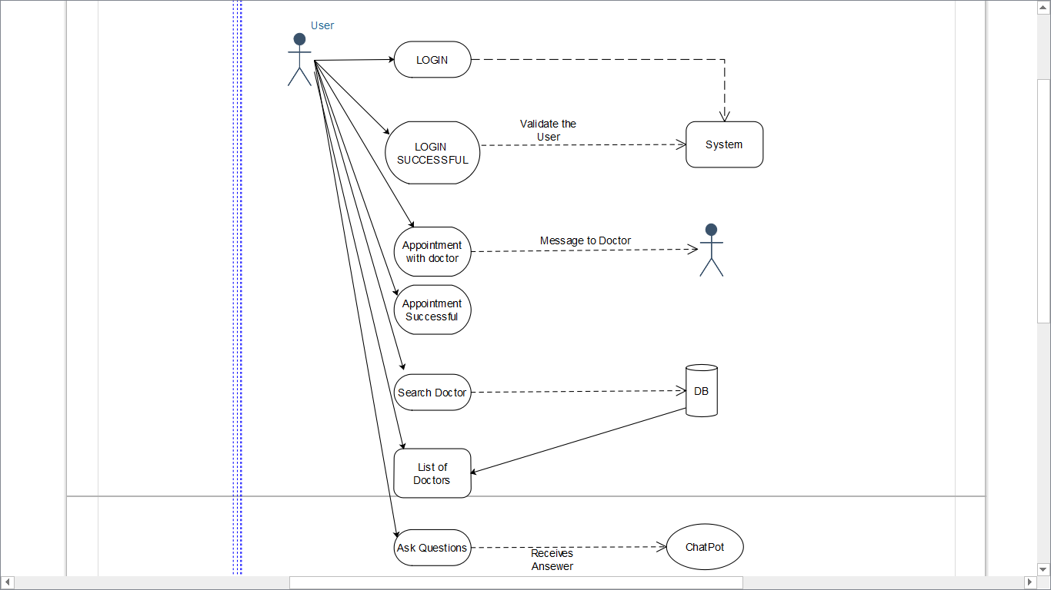

- Entity Relationship Diagram

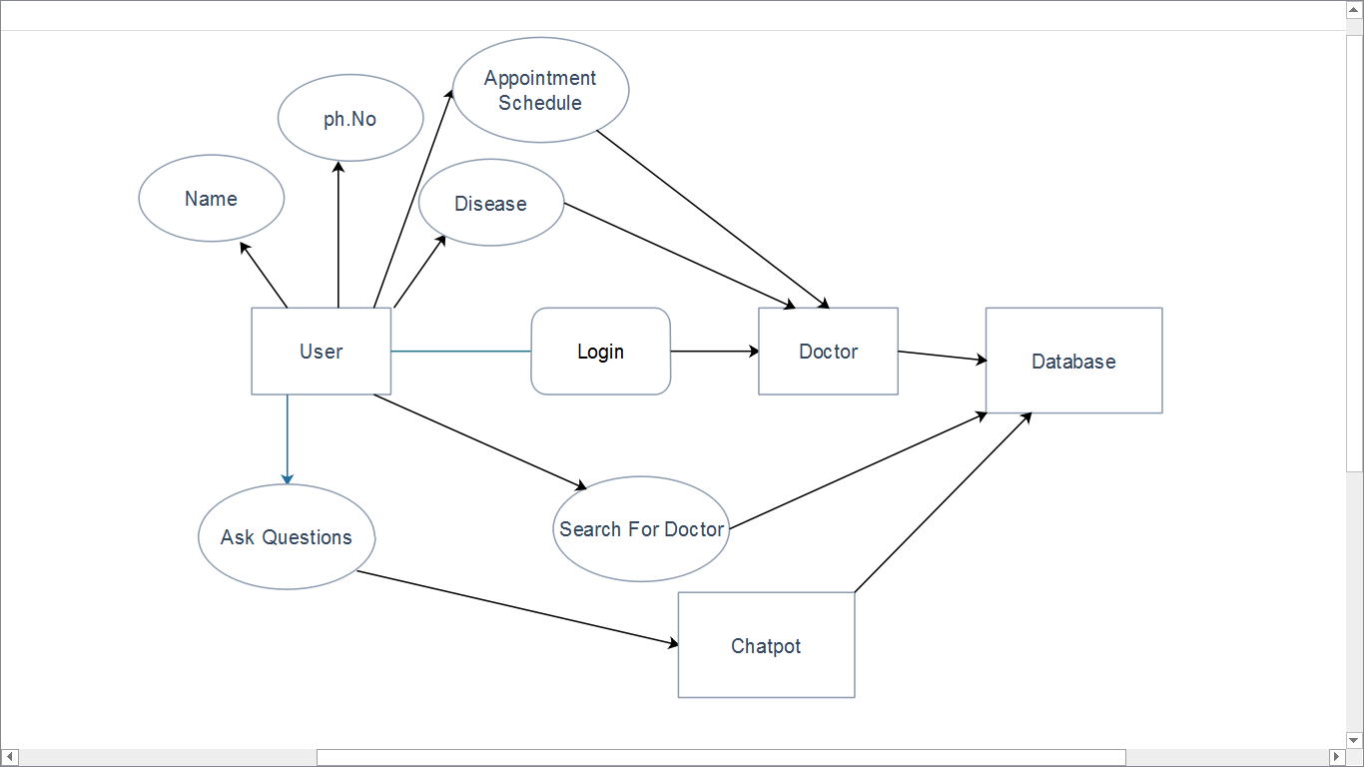

4.4 Dataflow Diagram

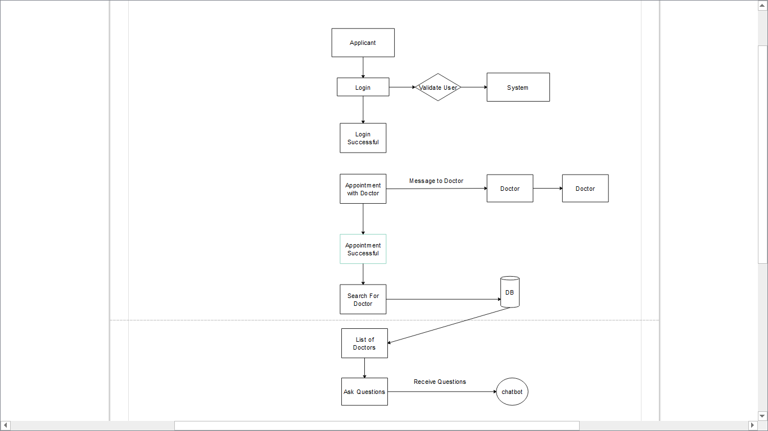

4.5 Screenshots

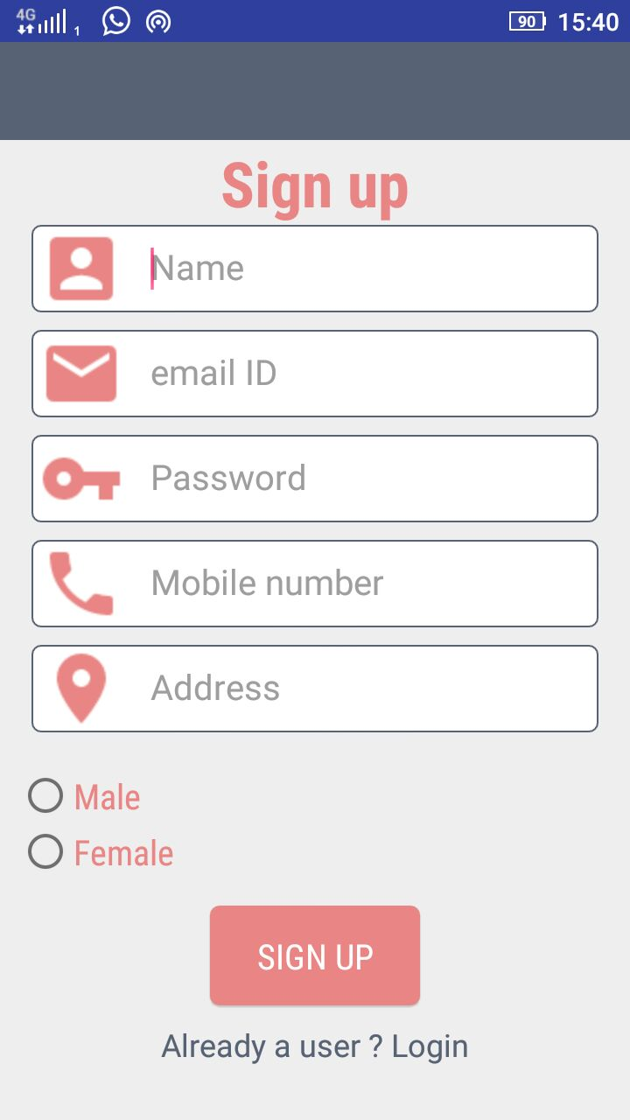

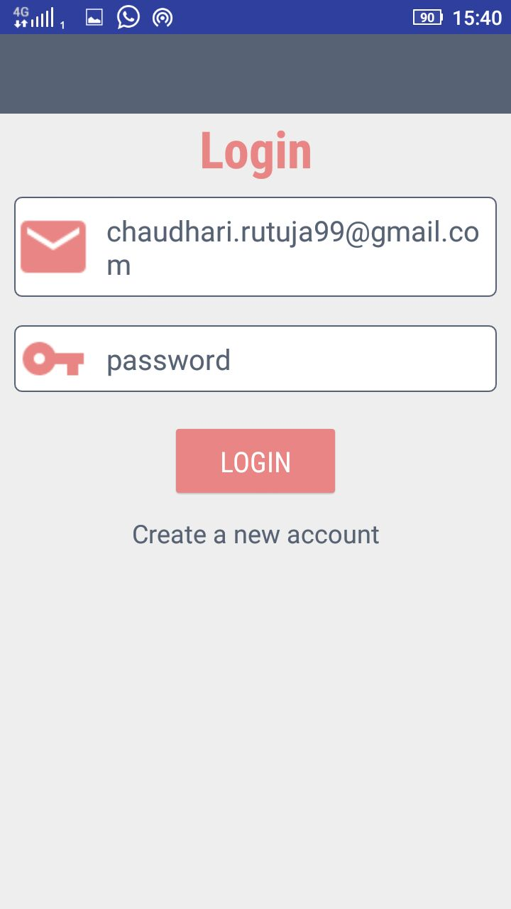

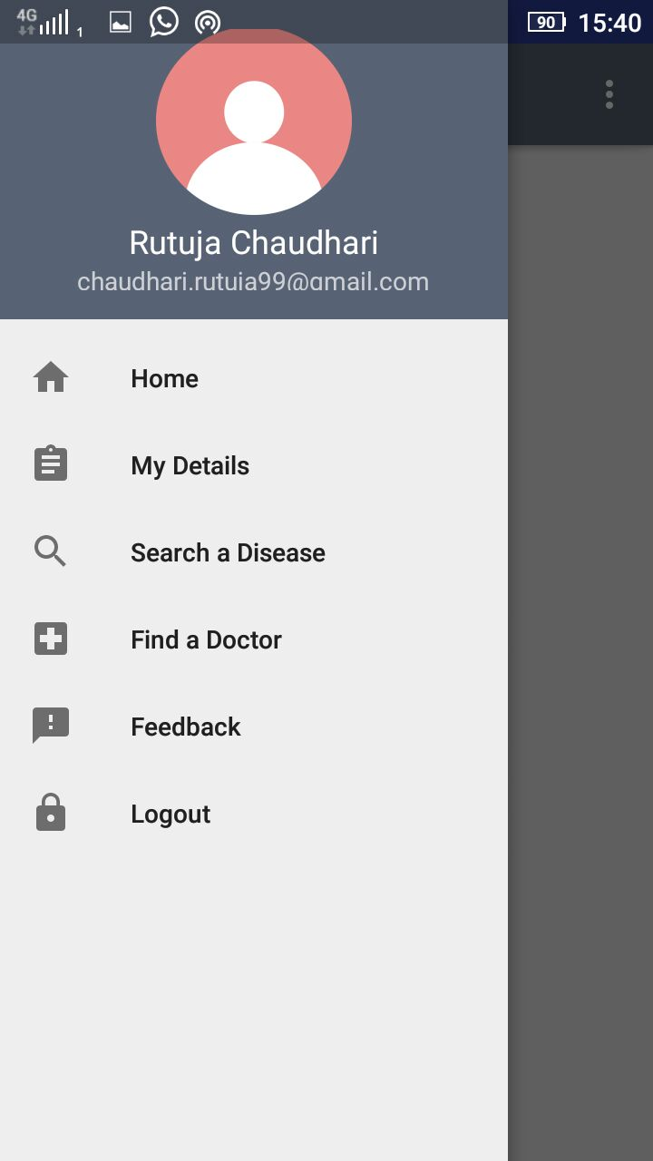
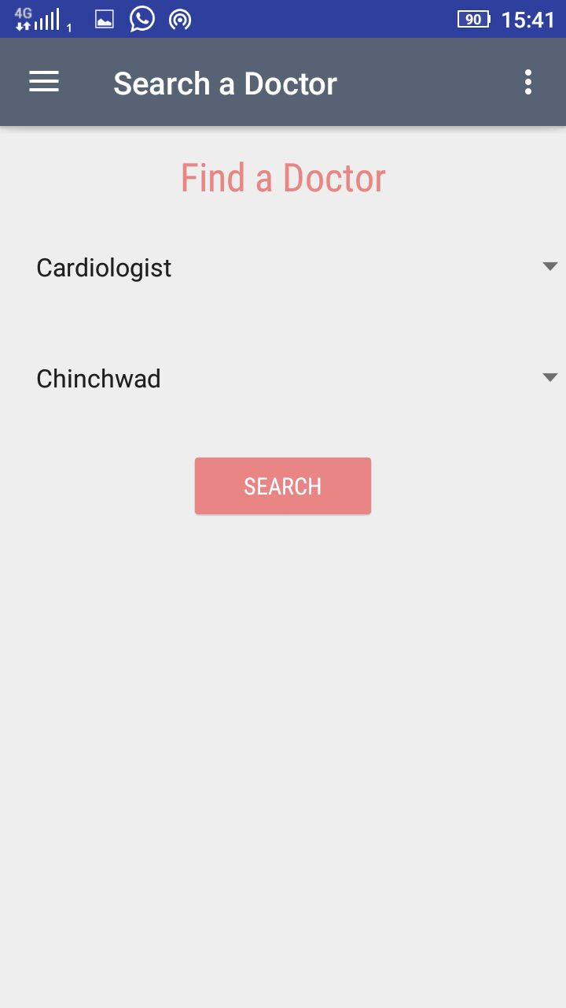

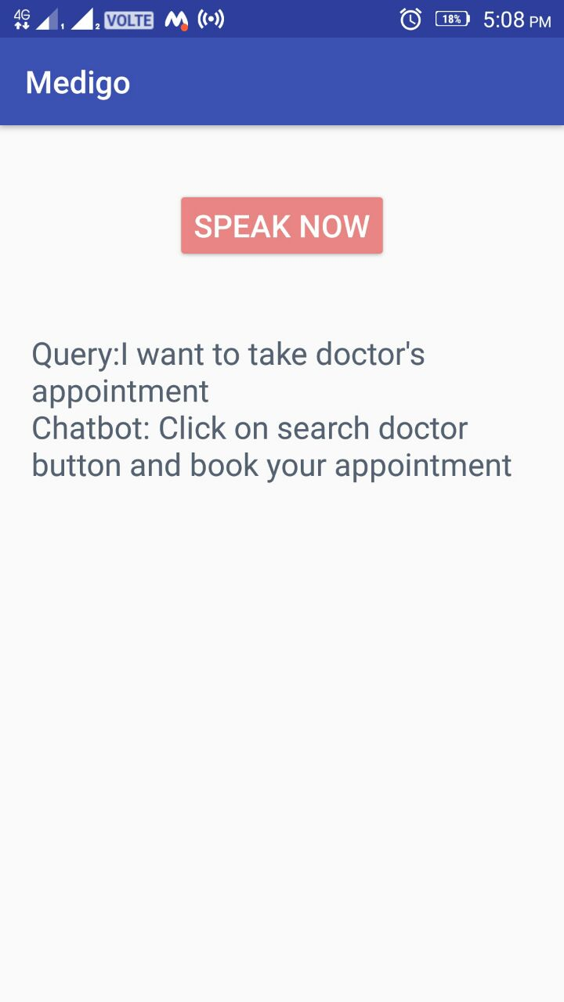

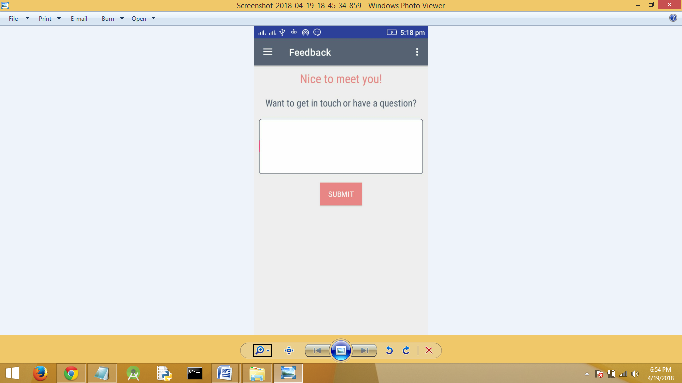

Chapter 5-System Development

Health Plus is divided into various modules which make up its functionality. Each module is responsible for some activity. The different modules in Health Plus are:

- User Registration.
- Symptoms to Disease prediction.
- Uploading medical history.
- Finding doctors and getting appointments.
- Satisfying user queries through Chatbot and feedback.

5.1 User Registration module:

The User registration and Login module is responsible for recording the user details and inserting them into MYSQL database. The registration module asks the user from information such as full name, email ID, password, contact number, address, etc. The data is then transferred to the server for storing.
The Login module provides access to the user on Sign in. It checks for the valid email ID and password against the database and sends response to the client accordingly.
Here, the client is an Android application and the server is PHP, MYSQL is the database server.

5.2 Symptoms to Disease prediction system:

The Symptom to Disease prediction system asks the uses to enter the symptoms he/she is experiencing and predicts the disease the person may have. There are a set of questions the user needs to answer for the system to do the forecasting. They are as follows:

- Body pain?
Stomach pain - S Head pain - O Chest pain - R
- Temperature?
Hot - H Mild - M Cool - C
- Blood pressure?
Peak - P Normal - N
- Yellow skin/Urine?
True - T False – F

The system will then predict the possibility of a disease.

The algorithm used for prediction is Naïve-Bayes Algorithm.
In machine learning, naive Bayes classifiers are a family of simple "probabilistic classifiers base onapplying Bayes theorem with strong (naive) independence assumptions between the features.
Naive Bayes has been studied extensively since the 1950s. It was introduced under a different name into the text retrieval community in the early 1960s,^{[1]:488} and remains a popular (baseline) method for text categorization, the problem of judging documents as belonging to one category or the other (such as spam or legitimate, sports or politics, etc.) with word frequencies as the features. With appropriate pre-processing, it is competitive in this domain with more advanced methods including support vector machines.^{[2]} It also finds application in automatic medical diagnosis.
Naive Bayes classifiers are highly scalable, requiring a number of parameters linear in the number of variables (features/predictors) in a learning problem. Maximum-likelihood training can be done by evaluating a closed-form expression,^{[1]:718} which takes linear time, rather than by expensive iterative approximation as used for many other types of classifiers.
In the statistics and computer science literature, naive Bayes models are known under a variety of names, including simple Bayes and independence Bayes.^{[4]} All these names reference the use of Bayes' theorem in the classifier's decision rule, but naive Bayes is not (necessarily) a Bayesian method.

5.3 Uploading medical history:

The application allows users to upload their medical details/history for assessment by the doctors. Health Plus presents users with a form which contains several fields to collect medical information. This information is send to the server for future use. The user can also view this uploaded information in future. He can also update his medical history from time to time.

The medical history has the following fields:
- Age.
- Diseases than apply to the person or his immediate family.
- Symptoms he/she is currently experiencing.
- Medication allergies he/she may have.
- Medication he/she is currently taking.
- Pregnant or not?
- History of tobacco use?
- History of illegal druguse?
- Amount of alcohol consumption.

5.4 Finding doctors and getting appointments:

Once logged in, the user to free to search for different specialized doctors by using this module. This module provides the user with two drop down lists which are as follows:
- Doctor category
- Location
The user can look for a specific category of doctors under a particular location boundary. These values are sent to the server for processing. The server queries the database for doctors under the specified category and location. The result is sent back to the client and presented in a RecyclerView in Android.
The user is also able to get the appointment of any doctor. On appointment booking both the doctor and the patient receive an email regarding appointment conformation.

5.5 Satisfying user queries through Chatbot and Feedback:

User if in dilemma can send his/her queries to the system for solution. This is facilitated by two sub-modules:
- Chatbot
- Feedback
The Chatbot uses API.AI Dialogflow provided by google which allows to buid chatbot. It has certain Intents where we can add question and answers.We firstly create agents which include the intents. We can also add SmallTalks such as greetings.
Feedback on the other hand allows user to send his/her valuable comments, queries to the helper team. The team can then provide solutions to his/her problems.

Chapter 6-System Testing

6.1 Test Case 1

Testcase ID | TestCase Title | Data | Expected result | Actual Result | Status
QWE123 | To validate username field. | Number entered in username field | Invalid | Invalid | Pass
 |  | Characters entered in username field | Valid | Valid | Pass
 |  | Username left Blank | Invalid | Valid | Fail
QWE124 | To validate email_ID field. | '@'sign missing in email id field | Invalid | Invalid | Pass
 |  | Email id in correct format | Valid | Valid | Pass
 |  | Characters entered in upper case | Invalid | Valid | Fail
QWE125 | To validate password field. | Password length is less than 6 | Invalid | Valid | Fail
 |  | Special character entered | Valid | Valid | Pass
 |  | Password left blank | Invalid | Invalid | Pass
QWE126 | To validate Mobile number field. | Entered phone number length is greater than 10 | Invalid | Valid | Fail
 |  | Phone number left blank | Valid | Valid | Pass
 |  | Phone number is less than 10 | Invalid | Invalid | Pass
QWE127 | To validate Adrdess field | Address length is less than 40 | Valid | Valid | Pass
QWE128 | To validate SignUp button | Data is submitted | Valid | Valid | Pass
 |  | Data insufficient | Invalid | Invalid | Pass

 | 6.2 TestCase 2
Test ID | Test Case Title | Data | Expected Result | Actual Result | Status
AS12 | To validate doctor categary | 1.Select the category | selected | selected | Pass
 |  | 2.Display the category | valid | valid | Pass
AS13 | To validate doctor City | 1.Select the city | selected | selected | Pass
 |  | 2.Display the city | valid | valid | Pass
AS14 | To vaidate search button | 1.Click on search | valid | valid | pass

Chapter 7-Conclusion

Health Plus is an Android Application which assists the user to perform many tasks with ease such as getting appointments of specialized doctors online, uploading their medical history from time to time, searching for specific doctors, recording symptoms to forecast the disease he/she may have. Health Plus is very beneficial to patients as all the features are amalgamated into the same application. The system is simple to use and has an interactive UI.

Chapter 8- Future Scope

Health Plus with all its combined features provides a solution to many problems the user may face. Due to its simple user interface, the application is easy to use. By combining the power of Health Plus with fast Machine Learning algorithms it is possible to extend the capabilities of this application in the near future. Google Maps can also be integrated with Health Plus to find the nearby doctors.

Chapter 9-References

https://dzone.com
https://developer.android.com
https://javapoint.com
https://tutorialspoint.com
https://journaldev.com

